**PRIORITY QUEUE**

Create a priority queue with the menu:

**[DATA DISPLAY]**

1. **Give an Order**

The inputted data is **ORDER** and **PRIORITY.** Input the data to the queue based on the priority.

1. **Do an Order**

Do the highest order in the linked list.

1. **Clear All Orders**

Clear the linked list.

1. **Exit**

Exit the program.

**Give an Order**

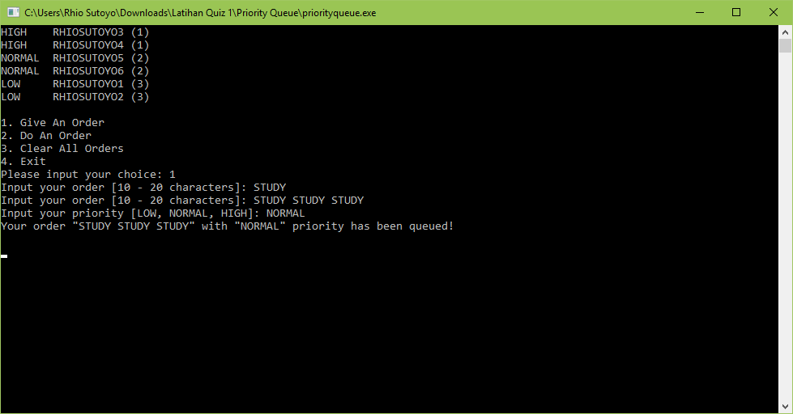

**Do an Order**

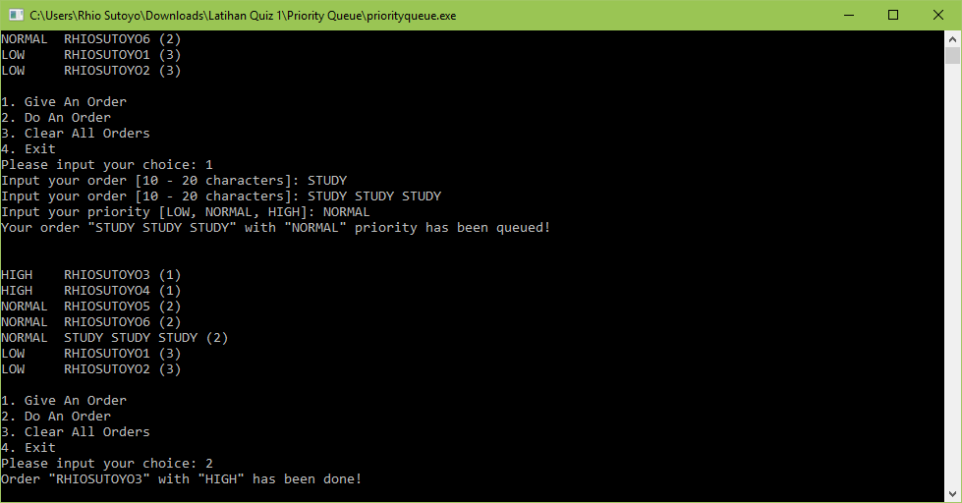

**Clear All Orders** 